Noon Payments plugin for WooCommerce

Supported WooCommerce: 3.7, 3.8, 3.9, 4.2, PHP 7.3+

Caution: Always keep backup of your existing WooCommerce installation including Mysql Database, before installing a new module.

Install via WordPress plugin Installer:-

1. Login to WordPress Admin panel and goto Add New Plugin. Then click on Upload Plugin.

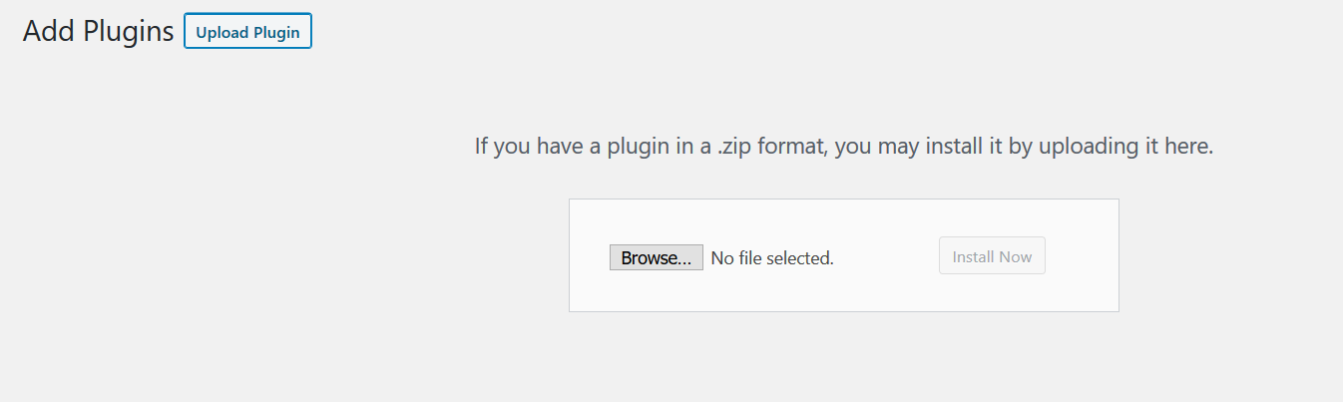

1. Choose this downloaded zip and click Install Now.

Manual Installation:-

1. Unzip and copy ‘WooCommerce_Noon’ folder from this zip and paste/upload it to <wordpress root>\wp-content\plugins folder.
2. Login to WooCommerce admin and goto Plugins. Activate the plugin.

Configure Module:-

1. Login to WordPress admin and open WooCommerce Settings. Click on the payments tab.

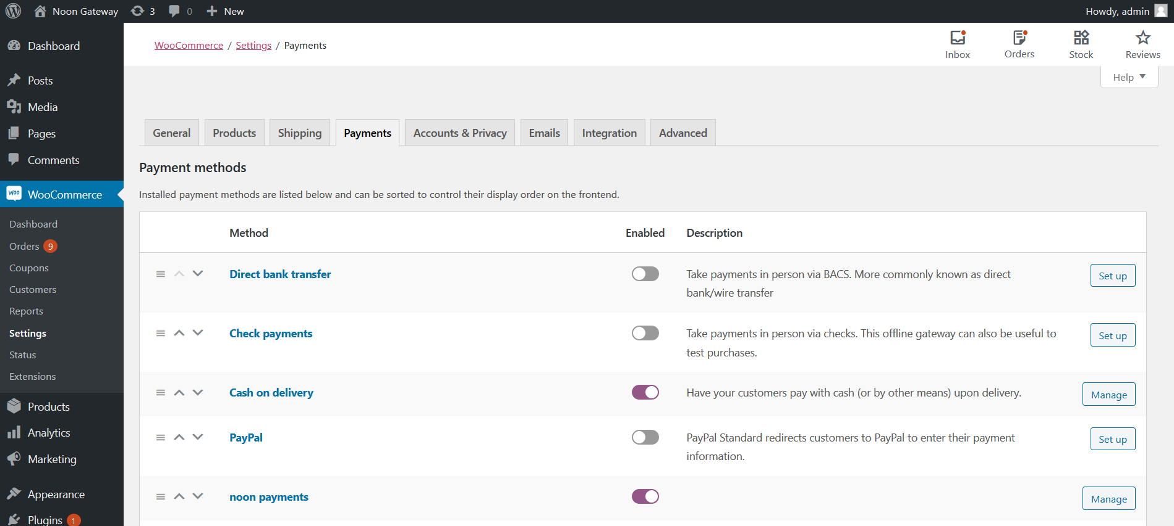

1. Click on “Setup first time then “Manage”

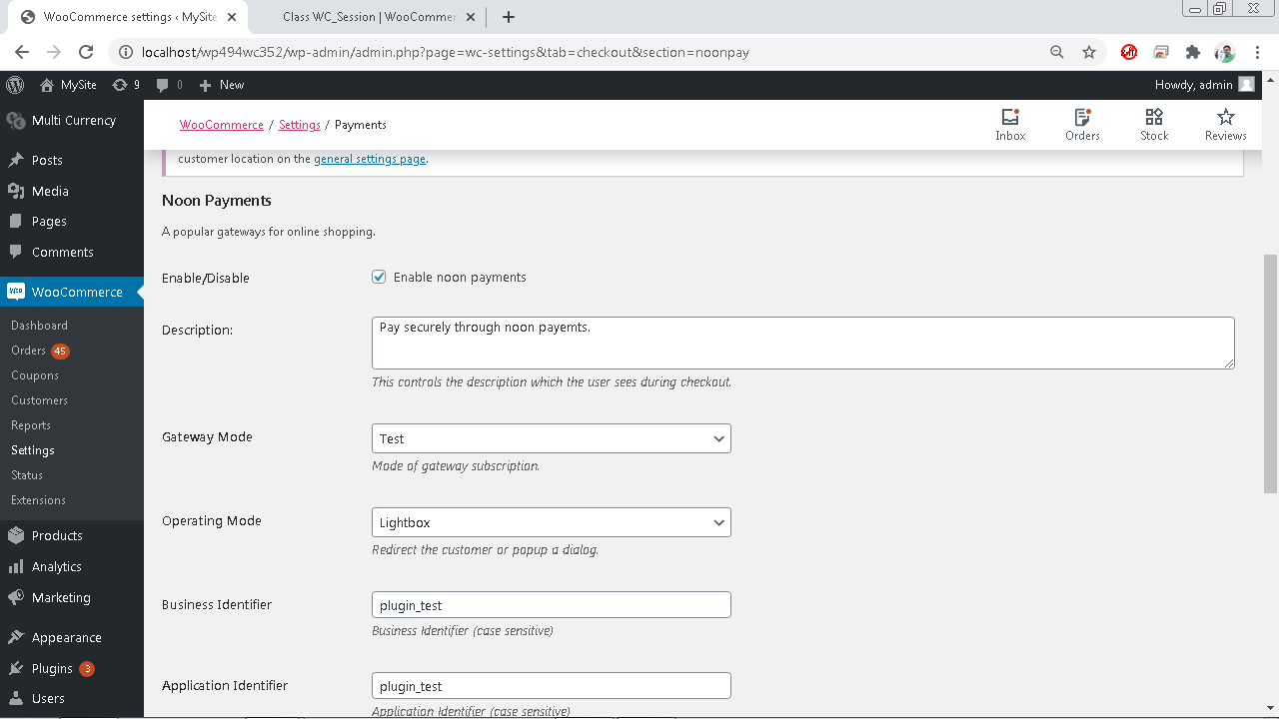

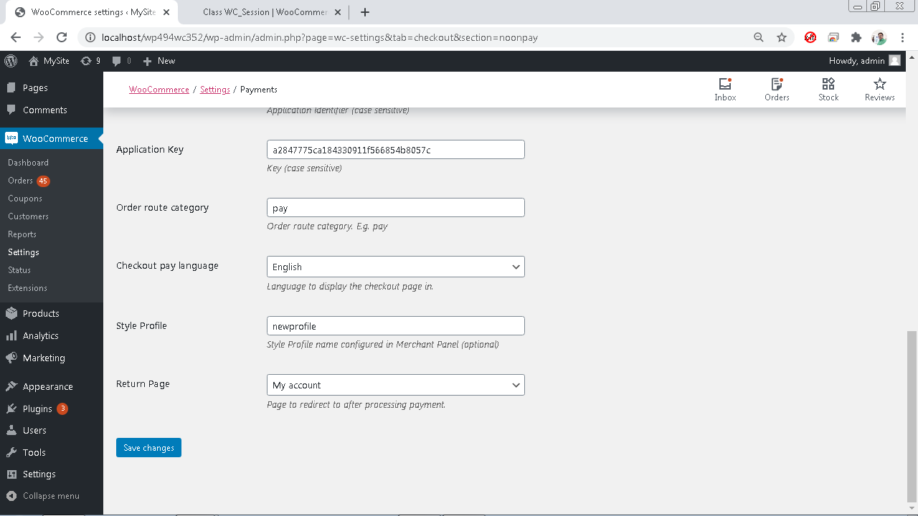

* + Enable/Disable – Tick to enable the module.
  + Description – Enter appropriate description to display at checkout.
  + Gateway Mode - “Test” for sandbox/test operation and “Live” for live operation.
  + Operating Mode – Choose “Lightbox” or “Redirect”
  + Business Identifier – As configured in merchant panel.
  + Application Identifier – As configured in merchant admin panel.
  + Application Key – As configured in merchant admin panel.
  + Order Route Category: As configured in merchant admin panel.
  + Checkout Pay Language: Use gateway supported language. E.g. en,ar
  + Return Page – Page to return to after payment is complete

Note: Noon Payments supported currencies are USD, AED, SAR, EGP and KWD. Appropriate currency must be passed during checkout for success.

1. Now click save and customer will get noon payments option during checkout process.

